Comparative Study: Custom CNN vs ResNet152 for Thermal Map Prediction
DIVYANSHU SINGH V.RAMAKRISHNA KRISHNA YADAV

1. Introduction
This document presents a detailed comparative analysis between a Custom CNN model and a ResNet152 model for thermal map prediction. The evaluation focuses on numerical accuracy, structural learning, robustness, and practical applicability in real-time thermal management systems.

2. Quantitative Performance Comparison
- Custom CNN demonstrates superior numerical accuracy with MAE ≈ 0.91°C,
- while ResNet152 shows MAE ≈ 1.19°C and RMSE ≈ 1.77°C.
- ResNet152 achieves PSNR ≈ 33.53 dB and SSIM ≈ 0.9108, indicating good structural similarity but weaker regression performance.
- A negative R² score (-2.0966) for ResNet152 highlights poor regression fit, while CNN maintains stable and reliable predictions.
Metric | ResNet152 | CNN | Better Model
Train Loss | 0.000674 | 0.000666 | ≈ Same
Val Loss | ❌ 0.000930 | ✅ 0.000505 | CNN
Train MAE | ✅ 0.0180 | 0.0192 | ResNet (slightly)
Val MAE | ❌ 0.0196 | ✅ 0.0151 | CNN
Train RMSE | ≈ 0.02597 | ≈ 0.02581 | Same
Val RMSE | ❌ 0.0305 | ✅ 0.0225 | CNN

2. OVERFITTING ANALYSIS

ResNet152:
- Train Loss: 0.00067
- Val Loss: 0.00093 (higher)
Gap = Overfitting
CNN:
- Train Loss: 0.00066
- Val Loss: 0.00050 (even lower!)
Gap = Excellent generalization

Although ResNet152 is a deeper architecture, it overfits due to limited data and produces noisier predictions. The simpler CNN model achieves better generalization, lower validation error, and smoother thermal outputs, making it more suitable for this task.

RESNET152
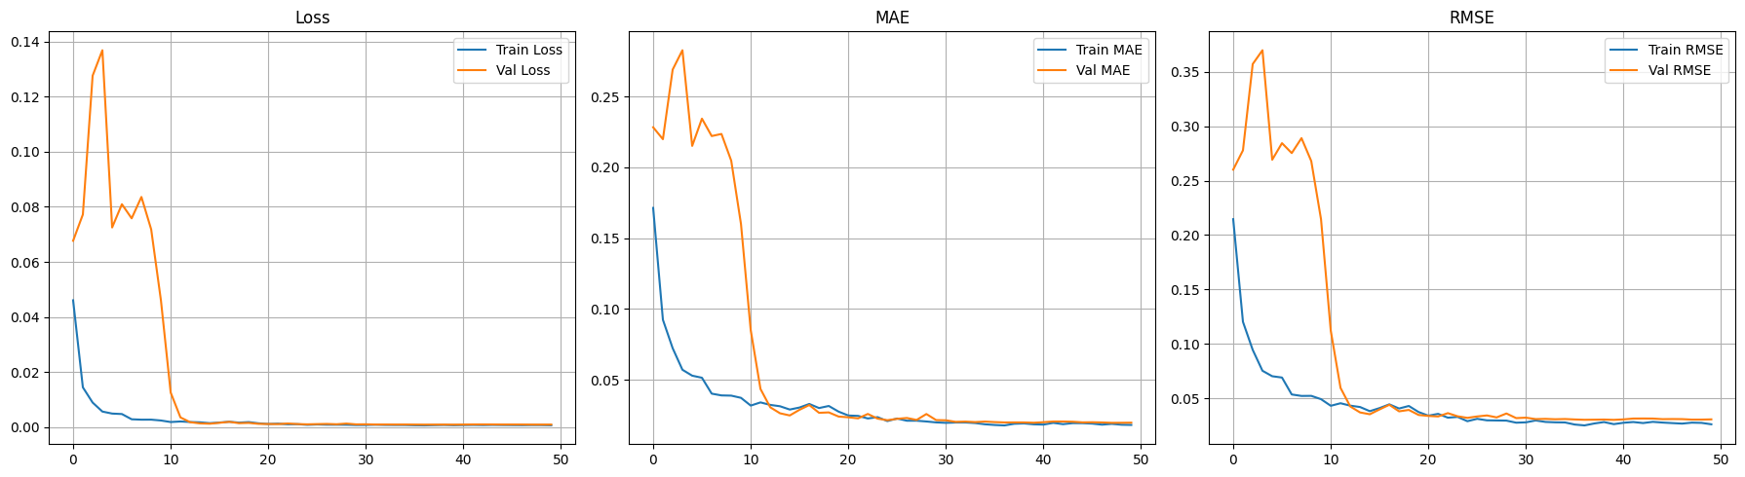

CNN
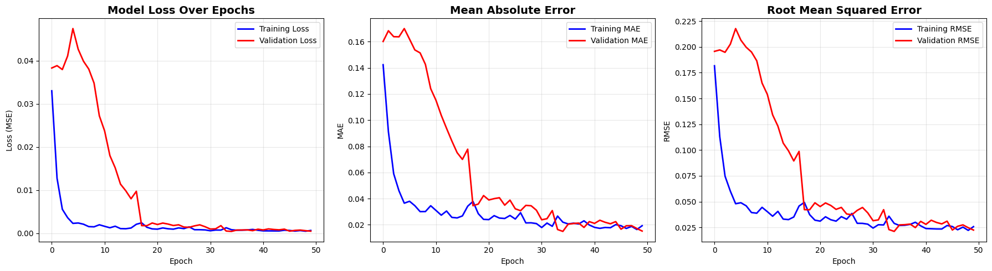

MODEL LEARNING
Metric | ResNet152 | CNN | Winner
PSNR | 33.53 dB | 36.17 dB | CNN
SSIM | 0.9108 | 0.9606 | CNN
MSE | 0.000795 | 0.000429 | CNN
RMSE | 0.0282 | 0.0207 | CNN
MAE | 0.0191 | 0.0145 | CNN
RMSE (°C) | 1.77°C | 1.30°C | CNN
MAE (°C) | 1.19°C | 0.91°C | CNN
Max Error | 21.39°C | 14.98°C | CNN
R² Score | -2.0966 | 0.9935 | CNN

CNN:
- Higher PSNR → better reconstruction quality
- Higher SSIM → better structure preservation
- Lower RMSE/MAE → more accurate predictions
- R² ≈ 0.99 → almost perfect variance explanation

ResNet152:
- Lower PSNR → poorer reconstruction
- Lower SSIM → weaker structure
- Higher errors

3. Structural vs Numerical Learning
ResNet152 excels in capturing spatial structures and hotspot regions, as indicated by high SSIM values. However, it struggles with precise temperature estimation, leading to higher errors.
The Custom CNN balances both spatial understanding and numerical accuracy, making it more suitable for regression-based thermal prediction tasks.
DISTRIBUTION ANALYSIS
- ResNet152 shows high variance in PSNR values (19–41 dB), indicating inconsistent pixel-level accuracy.
- CNN exhibits more stable and consistent performance across samples.

PSNR: Higher the value, better it is!
SSIM: Closer to 1, better value it is!

CNN
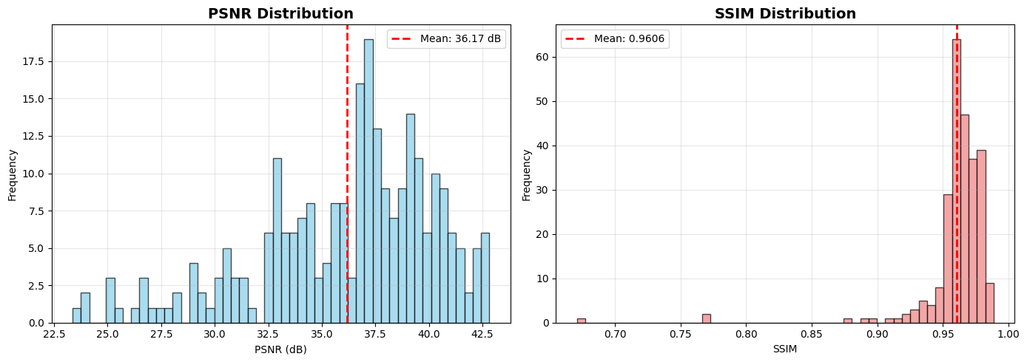

RESNET152
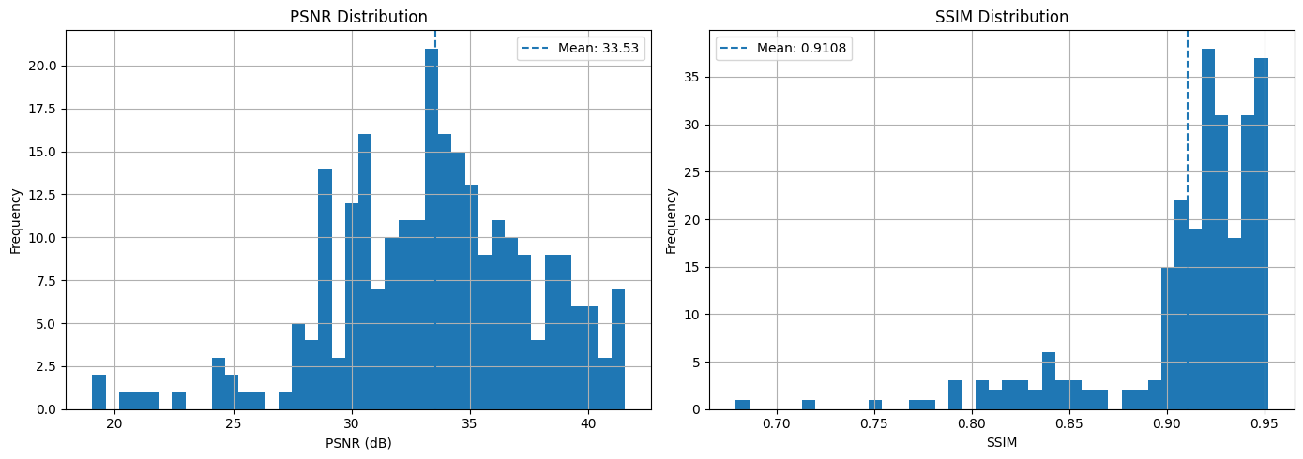

4. Heatmap Analysis
CNN produces smoother thermal maps with consistent gradients and lower noise.
ResNet152 correctly identifies hotspots and preserves structure but introduces noise and less smooth transitions.

RESNET152
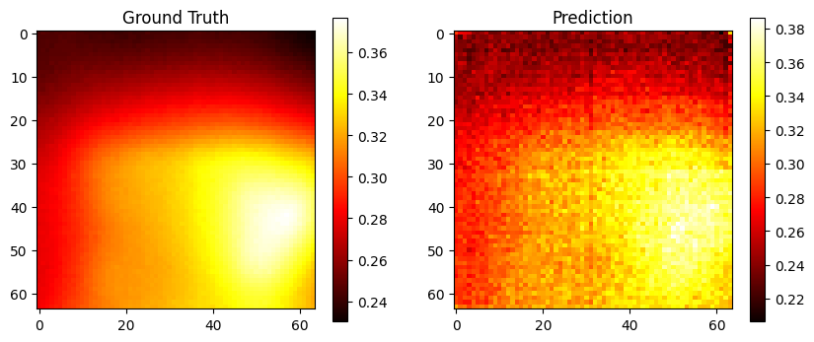

CNN
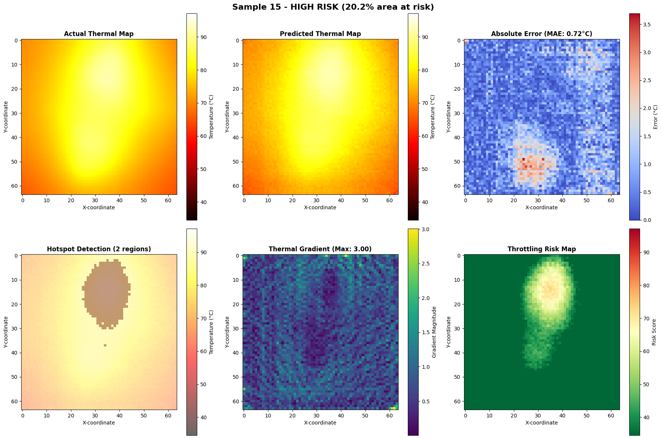

5. Reasons for ResNet152 Underperformance
1. Overfitting to spatial features rather than numerical precision.
2. Designed primarily for classification, not regression.
3. Requires large datasets; limited data affects performance.
4. Residual connections may introduce noise in pixel-wise predictions.

6. Practical Implications
- CNN is more suitable for real-time thermal prediction and precise temperature estimation.
- ResNet152 is better for identifying complex spatial patterns and hotspot localization.

7. Final Conclusion
The study concludes that while ResNet152 captures structural patterns effectively, it underperforms in numerical accuracy. The Custom CNN model achieves better balance between spatial and numerical learning, making it more suitable for real-world thermal management systems.

